**TASK 3 REVIEWING YOUR PORTFOLIO**

**EXPLAIN HOW THE FINAL PORTFOLIO IS SUITABLE FOR THE INTENDED AUDIENCE AND PURPOSE. (**2C.P6)

Based on my output, I believe the portfolio meets the intended audience and purpose. The portfolio was built/developed right from scratch and published online. From the assignment brief, since the site is hosted on a server the employer ‘**KONNEKTED**’ can access and view it at any point in time. The portfolio includes a range of work and resources such as (written documents, images, programmes etc) created during the course which is made available to everyone and can be downloaded easily. Overall, the portfolio showcases a list of all resources (assets) thereby fulfilling the intended audience and purpose.

**REVIEWING THE EXTENT TO WHICH THE FINAL PORTFOLIO MEETS THE**

**NEEDS OF AUDIENCE AND PURPOSE, CONSIDERING FEEDBACK FROM**

**OTHERS (**2C.M5)

The portfolio has to leave along lasting impression on the employers ‘**KONNECKTED**’ and to stand out among other apprentice during the application process. The portfolio has a great colour scheme, layout and structure. It is categorised into different sections with the main page linked to other pages. Based on the feedbacks I received, have made some further improvements and testing to make the portfolio better.

From the feedback I received:

**Improvements -** Since I decided to include screenshots on each unit’s page, there were some missing parts resulting in an empty box being displayed.

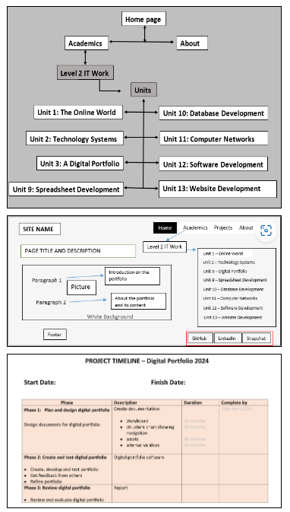**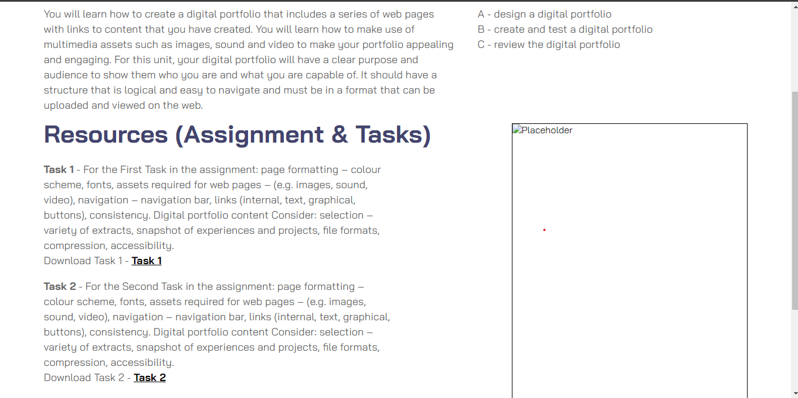Before Change: After Change:**

**Improvements –** Another issue I needed to improve; was to re-structure the heading ‘**Resources (Assignment & Tasks)**’ overlapping the unit description.

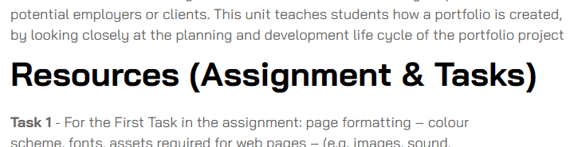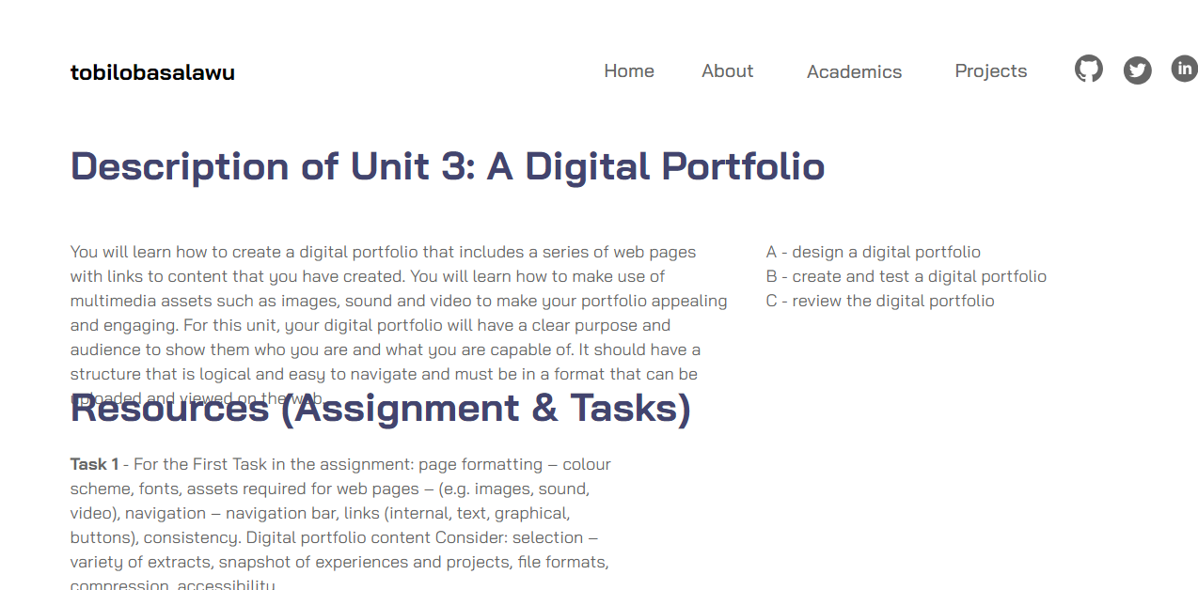**Before Change: After Change:**

**Additional feedback received from – (**Jane Franklin):

Jane stated that there were a few grammatical errors in the unit’s description which I needed to correct. She also stated that I have to add a list of screenshots to each unit just as required in the assignment brief.

**PS:** Due to the fact that this additional feedback was received a bit late, I did not capture any screenshots of the previous structure of the pages right before I updated it. But all improvements have been made.

**JUSTIFYING THE CHNAGES MADE (STORYBOARD)**

Social media links

Picture

Paragraph

Site name

MENU

On the homepage, the difference between the storyboard and final design is that; I placed the social media links on top, right in front of the menu instead of placing it on the footer. Moreover, I also included a button to navigate users to ‘**projects**’ page to improve the usability and experience of the portfolio.

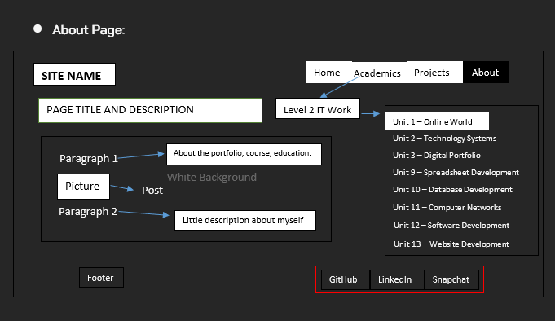

Little description

Site name

Social media links

MENU

From the screenshot above, the about page had little changes made to it. The description on the course I intended to place from the storyboard, I pushed it into the level 2 IT work page. As it matches and resonates with that section of the portfolio than the **‘About**’ page.

Overall, based on my justification the screenshots placed above are the only pages I made significant changes to, the rest matches the initial design (storyboard) I created.

**EVALUATING THE FINAL DIGITAL PORTFOLIO AGAINST THE INITIAL DESIGNS AND JUSTIFY ANY CHANGES MADE, MAKING RECOMMENDATIONS FOR FURTHER IMPROVEMENTS. (**2C.D3)

There were a few changes made to the final portfolio against the design of documentation(**storyboard**). I did not include a product page on the navigational structure of the portfolio, but it was still part of my initial design in the storyboard. The page includes a description of the projects have completed with a hyperlink to it.

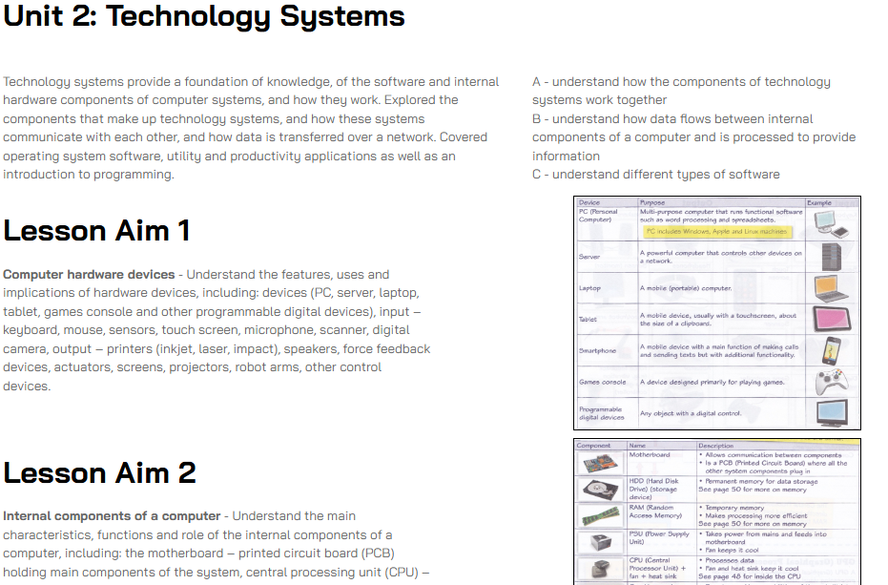

From the recommendation I received from my teacher (Jane Franklin), I decided to include screenshots of the activities such as assignments & tasks I completed for each unit during the course.

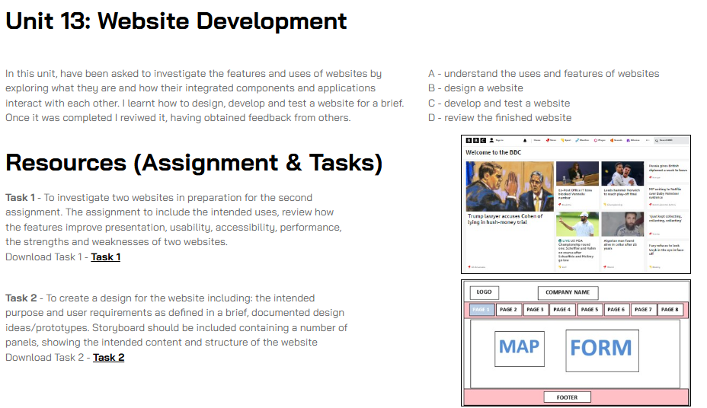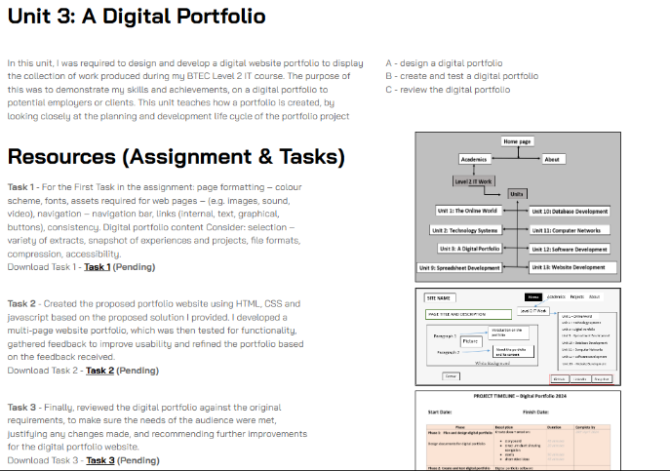

**I recommend improving the website by:**

* Add more description on the about page, which would help users understand a bit more on person’s life and career in general.
* Better quality of images and screenshots should be uploaded on units’ page to improve usability and user experience.